God Keeps His Promises Craft:

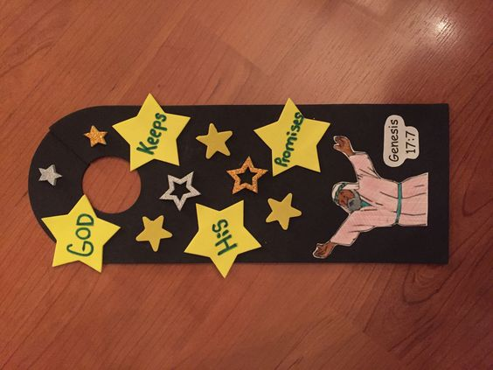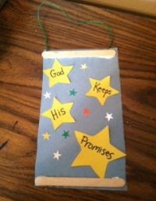
This banner will help remind children that God keeps his promises, just like the promise kept to Abraham and Sarah.
Supplies List:

- Large & Small Star Shapes
- Glue
- Blue or Black Construction Paper
- Craft Sticks
- Yarn
- Sticker Stars

- If you want to include a picture of Abraham, use Coloring Page 2 from activity list
Instructions:
- Give children the blue piece of construction paper and star shapes. Instruct them to write on the stars (one word per star) “God Keeps His Promises.” Instruct kids to glue the stars onto the blue or black paper.
- Children can at this point cut a hole or choose to add the string. If they add the string please follow these steps:
  - Give children two craft sticks and a piece of yarn.
  - Instruct them to glue the ends of the yarn to the top of the paper and then to glue the craft stick on top of the yarn. Finally, have them glue the other stick to the bottom of the paper.
- Encourage children to finish decorating banners with more sticker or sequin stars.

