Walk with Jesus Art Activity

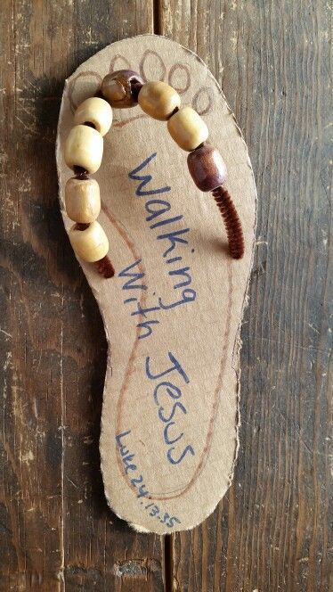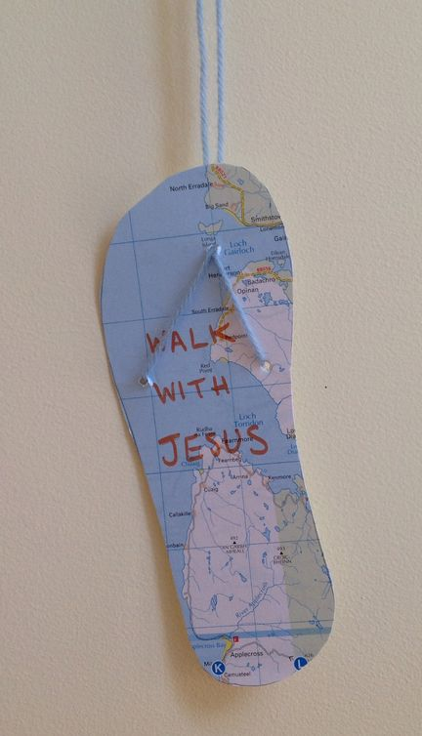

There are multiple ways to do this art activity. The key is to have cardboard or card stock and then trace your child’s foot. They can decorate the sandal however they like with a whole map (shown above), coloring or even stickers. You can also make the strap either with yarn, string or pipe cleaners and you can add beads (shown above) too!

